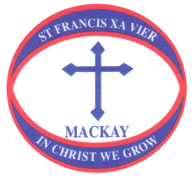
WHOLE SCHOOL EVENT
FEEDBACK FORM
Would you please complete the form below and place it the box provided in the school office. Alternatively, complete and save the feedback form then email the saved document to sfxm@rok.catholic.edu.au
Thank you for taking the time to provide some valuable feedback.
As a valued member of the St Francis Xavier School Community, we invite you to provide feedback on:

EVENT TITLE:
ASPECTS THAT WORKED WELL
SUGGESTIONS FOR IMPROVING THE EVENT IN THE FUTURE

OTHER COMMENTS

Name:
Date:

